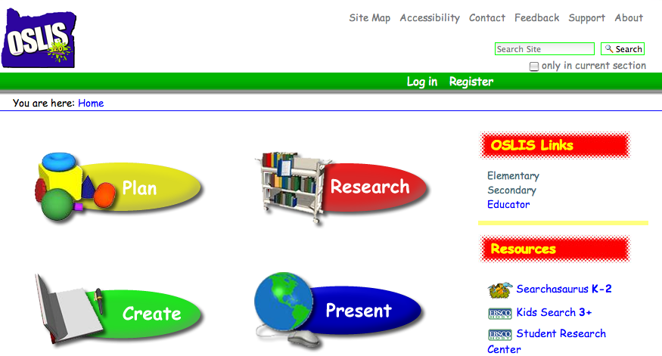
http://elementary.oslis.org

-Help Creating A+ Research Projects

-Easy School and Home Access to 100’s
of Online Research Resources

-Simple Online Citation Maker
for Your Bibliography Needs

Ask your librarian for details

