1/10/14
How to Create an Account on LearningExpress Library
There is not a district-wide login for LearningExpress Library like there is for access to the Gale databases. Instead, any K12 student or educator in Oregon who wants to use LearningExpress Library needs to create an individual account because each user needs a space to store tests, tutorials, and eBooks that they are taking or reading.
This is how to create an account:
- Access any Find Information page on OSLIS.
  - Secondary student: http://secondary.oslis.org/find-information
  - Secondary educator: http://secondary.educator.oslis.org/find-information
  - Elementary student: http://elementary.oslis.org/find-information
  - Elementary educator: http://elementary.educator.oslis.org/find-information
- Click on the LearningExpress Library link.
Secondary
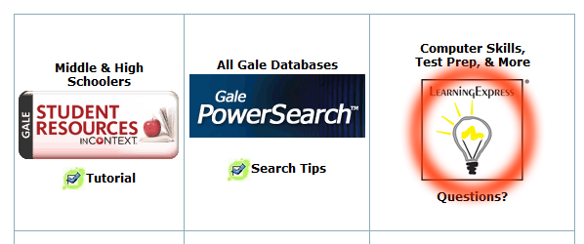
Elementary
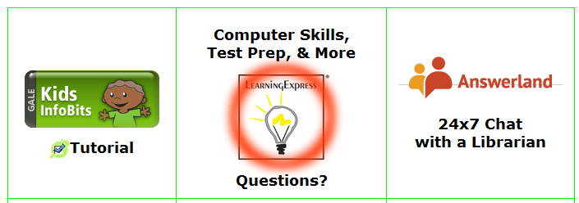

- Click on the larger LearningExpress Library logo, the one with 3.0 under it.
Note: Access to version 2.0 is only provided to allow previous users time to finish tests and tutorials in the old version. The link to 2.0 will be removed on July 1, 2014.
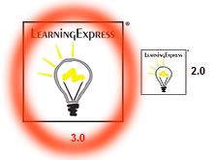
- Click on New user? Register in the bottom right corner.
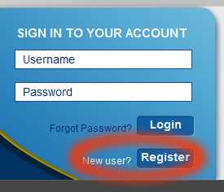

- Fill out the form and click on Create Account. If you do not have an email address, see 5a below.
Note: The email address you enter will become your username.
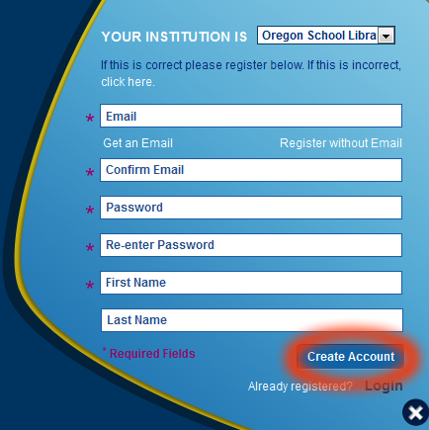
5a. Only if you do not have an email address, start by clicking on Register without Email.
That will lead to a different form. Click Create Account when done.
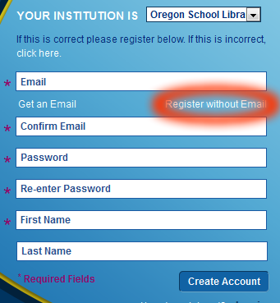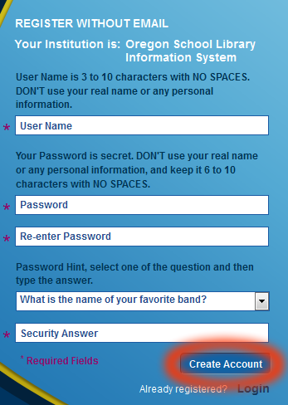
Questions? Contact your librarian or Jennifer Maurer, the School Library Consultant at the State Library.
jennifer.maurer@state.or.us || 503-378-5011

